**1. If the scores for a given sample distribution are:**

**32 32 35 36 37 38 38 39 39 39 40 40 42 45**

**Find the Variance and The Standard Deviation**

**Solution # 1:**

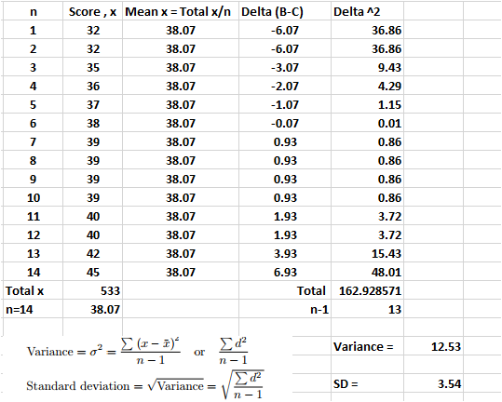

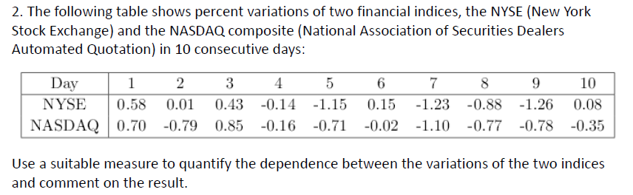

**Solution # 2:**

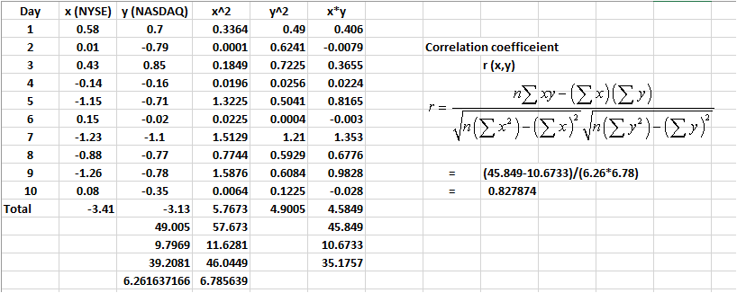

*x* and *y* have a strong positive linear correlation, since *r* = 0.82 is close to +1.  Positive values indicate a relationship between *x* and *y* variables such that as values for *x* (NYSE indices) increases, values for *y (NASDAQ indices)*also increase.